|  |
| --- |
| Version 2.0 May 2020 |
| China CITIC Bank  London Branch  Conduct Risk Policy Framework |
|  |



**Document History**

|  |  |  |  |
| --- | --- | --- | --- |
| **Author** | Chief Risk Officer | **Status** | Approved |
| **Version** | 2.0 | **Date** | May 2020 |
| **Approved by** | Management Committee | | |
| **Approved Date** | 22/5/2020 | **Next Review Date** | June 2021 |
| **Location** | London | | |

|  |  |  |  |  |
| --- | --- | --- | --- | --- |
| **Version** | **Owner** | **Approval** | **Date** | **Major changes** |
| 1.0 | President | President | May 2018 | PRA Regulatory Business Plan |
| 1.1 | CRO | MANCO | Oct 2018 | As per Manco Approval in Oct 18 |
| 2.0 | CRO | MANCO | May 2020 | * Appendix D – updated FCA questions on Conduct Risk (pages 18-22) |

Content

1 Introduction 4

2 Objectives 5

3 Framework Ownership 6

4 UK Senior Management and Certification Regime 7

5 CNCB Culture and Corporate Values 8

6 CNCBLB Risk Management Framework 9

7 Definition of Conduct Risk 10

7.1 Inherent factors of Conduct Risk to CNCBLB 10

7.2 Structures and Behaviours 11

8 Key Conduct Risks 12

9 Conduct Risk Events 12

10 The Conduct Risk Policy Framework 13

11 Conduct Risk Related Policies 14

12 Education and Training 14

13 Review and Update of Policy 14

14 Appendix A - CNCBLB Senior Management Functions 15

15 Appendix B – FCA Principles of Business 16

16 Appendix C – FCA Conduct Rules 17

17 Appendix D – FCA Conduct Risk Questions /Management Information 18

# Introduction

This policy document sets out China CITIC Bank London Branch’s (“CNCBLB’s” and / or “the Branch’s”) overarching Conduct Risk approach and outlines the underlying component parts that together makes up the way the Branch manages its Conduct Risk.

The Branch’s regulatory Permission permits it to undertake wholesale business only. Therefore, its customer base consists of both large corporate customers and financial institutions but no retail customer.

The Financial Conduct Authority (“FCA”) has specific focus on consumer outcomes and conduct risk. Historically this focus was on retail markets but there has been increased focus on the impacts of conduct risk for wholesale businesses and markets. It is important for financial institutions to establish a risk culture that not only addresses the risk of misconduct but also highlights clear accountability of actions through a preventive approach.

This is a challenging task as conduct risk cannot be pinpointed to a single function or business of a financial institution as these risks could be already entrenched within the business and operating model. Despite the consequences, Conduct Risk may arise in a number of areas across the product suite and CNCBLB is committed to ensuring all customers are treated fairly and that Conduct Risks are appropriately:

* identified at all points in the product life cycle;
* monitored and managed; and
* where risk crystallises, risks are dealt with promptly, appropriately and consistently.

CNCBLB maintains zero risk appetite for Conduct Risk failings and all employees must maintain a client focused service approach without any detriment to our clients.

# Objectives

This policy outlines the key Conduct Risks and the policies implemented to mitigate these risks as they arise as a result of CNCBLB’s business activities. An overview of the key Conduct Risks identified by the Branch can be found in Section 4 of this policy

The objectives of this framework document are to:

* Document, at a high level, how CNCBLB considers and manages Conduct Risk through a wide range of policies and compliance activities;
* Assign ownership and accountability for the maintenance of the Conduct Risk Policy document; and
* Support the implementation of CNCBLB’s Conduct Risk strategy and Conduct Risk Appetite which form part of CNCBLB’s overall Risk appetite.

.

# Framework Ownership

The ‘ownership chain’ for this framework document is outlined below:

|  |  |
| --- | --- |
| **Document Owner** | The Branch’s Chief Risk Officer (“CRO”) is responsible for the maintenance for this document.  The CRO will also be responsible for reviewing the ongoing adequacy of the policy framework on an annual basis or as required. Any material changes to this document will be communicated to staff accordingly. |
| **Oversight and challenge** | The Audit and Risk Committee (“ARCo”) will review and challenge this framework at least annually or more frequently as necessary  If an issue arising from this policy framework presents a material risk to the Branch or one of its customers then the CRO will escalate the matter to the ARCo, or the regulators as appropriate. Following each review of this document the ARCo will recommend approval or otherwise to The Management Committee (“ManCo”) |
| **Approval** | ManCo is responsible for the approval of this document. |
| **Applicability** | All members of staff, whether permanent (local hires and Expatriate alike) or contractors must operate in accordance with this framework document and all policies associated therewith. Escalation of any matters arising in respect of this should be through the individual’s Head of Department or directly to the CRO or Chief Compliance Officer (“CCO”).  To ensure compliance with the requirements of this policy the CCO will also conduct ad-hoc reviews as per the Branch’s Compliance Monitoring Programme. |

# UK Senior Management and Certification Regime

The Senior Managers Regime ensures that senior managers can be held accountable for any misconduct that falls within their areas of responsibilities, the new Certification Regime and Conduct Rules aim to hold individuals working at all levels in banking to appropriate standards of conduct.

The FCA published the final rules in 2015 and provided an overview of the requirements:

* **The Senior Managers Regime** focuses on individuals who hold key roles and responsibilities in relevant firms. This involves allocating and mapping out responsibilities and preparing Statements of Responsibilities for individuals carrying out Senior Management Functions (SMFs). While individuals who fall under this regime will continue to be pre-approved by regulators, firms will also be legally required to ensure that they have procedures in place to assess their fitness and propriety before applying for approval and at least annually afterwards.
* **The Certification Regime** applies to other staff who could pose a risk of significant harm to the firm or any of its customers. These staff will not be pre-approved by regulators and firms’ preparations will need to include putting in place procedures for assessing for themselves the fitness and propriety of staff, for which they will be accountable to the regulators. These preparations will be important not only when recruiting for roles that come under the Certification Regime but when reassessing each year, the fitness and propriety of staff who are subject to the regime.
* **The Conduct Rules** set out a basic standard for behaviour that all those covered by the new regimes will be expected meet. Firms’ preparations will need to include ensuring that staff who will be subject to the new rules are aware of the conduct rules and how they apply to them.

***Appendix A*** – Senior Management Functions

***Appendix B*** – FCA Principles for Business

***Appendix C*** – FCA Conduct rules

***Appendix D*** – FCA Conduct Risk Questions

# CNCB Culture and Corporate Values

CITIC Group are a multi-national conglomerate and have some entities listed on major stock-exchange markets. A significant part of the Group is China CITIC Bank (“CNCB” or “HO”) which is listed on the Hong Kong and Shanghai stock exchanges and regulated by the China Banking Regulatory Commission.

CNCB culture can be summarised in four key principles:

1. Pride in delivering world class service to ***customers***
2. Comprehensive financing service by providing value-creating financial solutions to ***customers***
3. Leverage off unique advantages of ***CITIC Group***
4. ***Employees*** - nurturing talent, team spirit and sharing ownership and success

The Bank’s Corporate Culture framework consists of five core elements, namely cultural inheritance, values, occupational norms, the motto oath and the logo of the Bank. The chapter on values include six parts, namely vision, mission, core values, business management philosophy, human resource philosophy and responsibility philosophy.

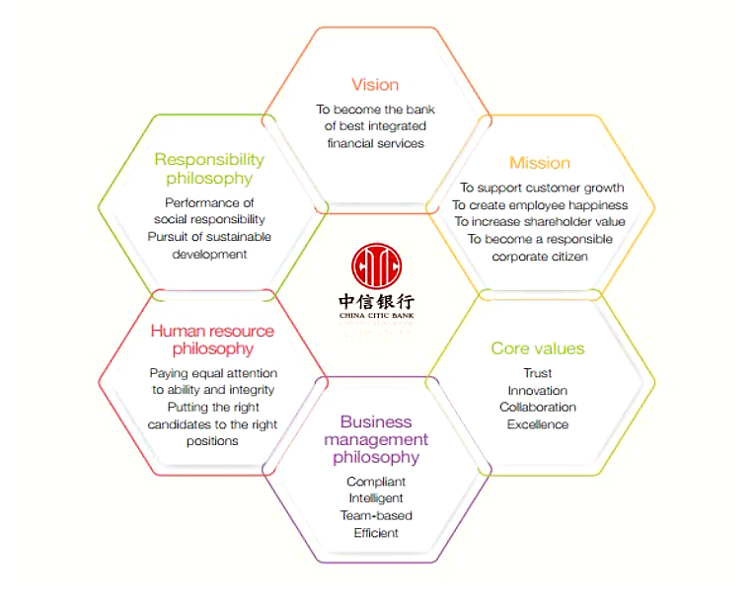An illustration of the Bank’s Corporate Values can be found in the figure below:

# CNCBLB Risk Management Framework

The Conduct Risk Policy is a supporting policy for the Operational Risk framework that is integral part of the overall risk framework, which is presented as follows:



Risk and Compliance departments will manage conduct risk through the life-cycle of transactions and customer relationships.

# Definition of Conduct Risk

CNCBLB defines Conduct Risk as the risk of customers being treated unfairly or being disadvantaged by the actions of the Branch and includes the potential for conflicts of interest between the Branch, HO and its customers. It also includes the risk of failing to meet market rules or standards, or general laws covering the Branch’s activities.

In determining the response to each Conduct Risk, the Branch considers both the ‘inherent’ risk (the risk before any mitigants have been implemented) and the ‘residual’ risk (actual risk remaining after mitigating action have been taken).

This is in line with the Risk Scoring Methodology which is set out in the Branch’s Risk Matrix, under the Operational Risk Policy.

## Inherent factors of Conduct Risk to CNCBLB

As a result of the nature of the activities conducted by the Branch there will be a number of Conduct Risks that need to be managed. The inherent factors of Conduct Risk that the Branch may be exposed to in the course of carrying on its business include, but are not limited to:

### Information Asymmetries

The products offered by CNCBLB are in the main, ‘plain vanilla’ products and are designed to be clear and transparent to customers. As the Branch’s customers are wholesale corporate and financial institution customers, it is expected that they are capable of understanding and assessing the suitability of the Branch’s products for their respective needs. However, the Branch and its staff will put controls in place to make sure that any information asymmetries between the branch and the customer are not exploited and that the customer will be supplied with a full set of information in order that they can make an informed decision in regards to the products offered by the Branch.

### Clear, fair and not misleading

It is expected that the majority of the Branch’s target customer base will be able to assess the suitability of the products and services they are offered both. Regardless, Branch staff will be provided ongoing training to ensure that all information provided to customers is clear, fair and not misleading to ensure customers have a clear understanding of the product/service they will obtain from the Branch.

### Inadequate Financial Capability

The Branch anticipates that its wholesale corporate and financial institution customer base has the necessary knowledge, experience to demonstrate sufficient financial capability when assessing their financial obligations both for the present and for the future. CNCBLB staff are trained to ensure that information given to customers is clear, fair and not misleading, and that customers can demonstrate a clear understanding of the product they are offered and the likely outcome of taking that product.

## Structures and Behaviours

Similarly, to the inherent factors considered above, the nature of the products and services could give rise to Conduct Risk arising through organisational structures and the behaviours of staff. These are outlined below:

### Conflicts of Interest

Branch staff are not and will not be incentivised to carry out transactions that are not in the customers’ interests and CNCBLB only offers vanilla banking and treasury products that will not be highly intermediated.

### Culture and Incentives

All CNCBLB staff are reminded that they are expected to conduct business with the utmost integrity and in line with the Conduct Rules. Staff will be provided ongoing training to ensure that customers are at the centre of their business. Staff will not be incentivised in any way which could result in conflicts arising and / or customer detriment occurring. The Conduct Rules and CNCBLB’s internal corporate values have been built in to annual performance reviews to ensure that an appropriate culture is encouraged and engrained in employee behaviour and in the activities they carry out.

### Ineffective Competition

CNCBLB does not offer products that allow it to apply undue market influence or create high barriers to entry. The products that CNCBLB offers will be transparent and open to market comparison and evaluation.

# Key Conduct Risks

The Conduct Risk policies of CNCBLB will cover five inherent, high level, Conduct Risks. These are listed in the table below:

|  |  |
| --- | --- |
| **Failure to take consider customer’s needs** | Can include the selling of inappropriate products to customers or inadequate ongoing review of products and services for customers, giving inappropriate advice to customers. |
| **Failure to treat customers fairly or to act in their best interests** | Can include providing misleading marketing information on products, pricing products inappropriately, failing to provide best execution of customer orders, failing to deal appropriately with customer complaints. |
| **Failure to meet required standards** | Intentionally or unintentionally failing to meet market rules or standards, or the general regulatory or legal framework within which business is done, including anti-bribery and corruption legislation or sanctions rules. |
| **Failure to implement systems infrastructure adequate to meet customers’ needs** | Where for example, operations and systems are set up in such a way that the ability on CNCBLB to transact business in a reliable and transparent manner is hampered by poor systems infrastructure and/or maintenance. |
| **Failure to deal with conflicts of interest** | CNCBLB may fail to deal with conflicts of interest with/between itself; customers and/or with HO. |

# Conduct Risk Events

The Risk Department will record all Conduct Risk Events and breaches of the conduct rules in the Operational risk ‘Incident/Near Miss Register, as defined in the Operational Risk Policy.

In addition, a list of possible Conduct Risk events is assessed in the Branch’s Risk Matrix, which is an integral part of the Operational risk management framework and is updated at least annually, through the Risk & Control Self-Assessment process.

All customer complaints will be taken seriously and reported to the CCO. In the event a customer makes any form of complaint, the Complaints process as set out in the Branch’s Complaints Handling Policy must be followed.

Any queries on the content of the conduct rules or whether an event you have witnessed or heard that may constitute a Conduct Risk, can be referred to either the CRO or CCO.

# The Conduct Risk Policy Framework

The CNCBLB Conduct Risk policies apply to all parts of the Branch as per the Three Lines of Defence Model.

Oversight of the Conduct Risk Management arrangements will be performed by the Branch’s CCO and reviewed by the ARCo.

In order to manage Conduct Risk effectively within the Branch each Conduct Risk related policy is required to:

* Clearly articulate the controls and actions to mitigate Conduct Risks;
* Detail any key documents underpinning the policy;
* Clearly identify policy owners;
* Detail how employees will be educated and trained to understand this policy; and
* Refer staff to this Policy Framework for instructions on action to be taken if there is an occurrence of a Conduct Risk Event.

To support the management of Conduct Risk, CNCBLB will determine and monitor a set of Key Risk Indicators (“KRIs”). The Risk Department will be responsible for the monitoring of these KRIs and on a monthly basis providing Management Information (“MI”) to the ManCo. If any KRI trigger thresholds are breached, this will be reported with a recommendation for mitigating action to both the CCO and the ManCo. The suite of KRIs and calibration of KRIs is still to be confirmed but will be reviewed at least bi-annually or as necessary once in place.

# Conduct Risk Related Policies

|  |  |
| --- | --- |
| The Branch’s Conduct Risk related policies apply to all parts of the Branch, including the support functions (e.g. Finance, Operations, HR, etc.) as well as the Second (Risk and Compliance departments) and Third (Internal Audit) Lines of Defence. The following policies assist management in managing Conduct Risk: **Policy** | **Owner(s)** |
| Risk Management Framework | Chief Risk Officer (“CRO”) |
| New Product Approval Policy | CRO |
| Conflicts Management Policy | Chief Compliance Officer (“CCO”) |
| Personal Account Dealing Policy | CCO |
| Gifts and Hospitality Policy | CCO |
| Market Conduct Policy | Vice President (“VP”) |
| Financial Crime Prevention Manual / Anti-Bribery Policy | Money Laundering Reporting Officer (“MLRO”) |
| Anti-Money Laundering Manual | MLRO |
| Anti-Bribery and Corruption Policy | MLRO |
| Financial Promotions Policy | VP |
| Complaints Handling Policy | CCO |
| Remuneration Policy | Head of HR and Administration |
| Training and Competency Policy | Head of HR and Administration |

# 

# Education and Training

All employees, as part of their annual training plans, will receive the necessary information and support to ensure they are familiar with their responsibilities under each policy affecting their role and to ensure they have an appropriate understanding of the Branch’s overall approach to Conduct Risk management. Where changes are made to policies, affected employees will be informed and provided with additional and timely training where necessary.

# Review and Update of Policy

The Conduct Risk Policy shall be reviewed by the Risk at least annually or as directed by the ManCo, to reflect changes in the profile of risks or business activities, organisational or authority structures or new regulations relevant to CNCB LB management of market risk.

# Appendix A - CNCBLB Senior Management Functions

|  |  |  |  |
| --- | --- | --- | --- |
|  | **Function** | **CNCBLB approved person** | **CNCBLB Title** |
| **SMF 19** | Head Overseas Branch | Jinlei Xu | President |
| **SMF 22** | Other Local responsibility | Gang Zhao | Vice – President |
| **SMF 22** | Other Local responsibility | Richard Thasis | Head of Financial Markets |
| **SMF 22** | Other Local responsibility | Di Wang | Head of Information Technology |
| **SMF 24** | Other Local responsibility | Anthony Chong | Head of Operations |
| **SMF 2** | Chief Financial Officer | Colin Marshall | Head of Finance and Accounting |
| **SMF 4** | Chief Risk Officer | Grant Lowe | Chief Risk Officer |
| **SMF 16** | Compliance | Rhod Sutton | Chief Compliance Officer |
| **SMF 17** | Money Laundering Officer | Rhod Sutton | Chief Compliance Officer |

# Appendix B – FCA Principles of Business

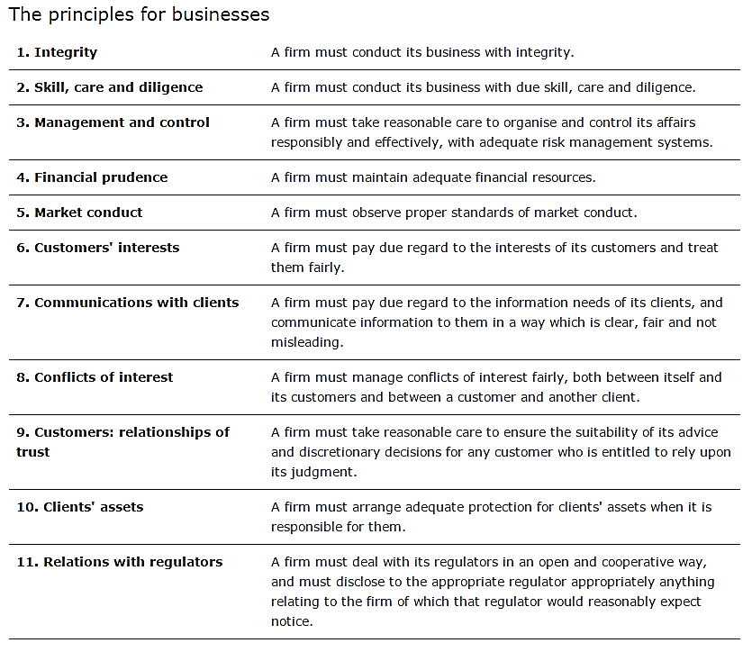

# Appendix C – FCA Conduct Rules

|  |
| --- |
| FIRST TIER: ALL STAFF (excluding auxiliary staff) |
| 1. You must act with **i*ntegrity*** |
| 1. You must act with ***due skill, care and diligence*** |
| 1. You must be open and cooperative with ***FCA, the PRA and other regulators*** |
| 1. You must pay due regard to the ***interests of customers*** and treat them fairly |
| 1. You must observe proper standards of ***market conduct*** |
| SECOND TIER: REQUIREMENTS FOR SENIOR MANAGEMENT ONLY |
| SM1  You must take reasonable steps to ensure that the business of the firm for which you are responsible is ***controlled*** effectively |
| SM 2  You must take reasonable steps to ensure that the business of the firm for which you are responsible ***complies*** with the relevant requirements and standards of the regulatory system |
| SM 3  You must take reasonable steps to ensure that any ***delegation*** of your responsibilities is to an appropriate person and that you oversee this effectively |
| SM 4  You must ***disclose*** appropriately any information of which the FCA or PRA would reasonably expect notice |

# Appendix D – FCA Conduct Risk Questions /Management Information

|  |  |  |  |
| --- | --- | --- | --- |
|  | **FCA expectations** | **CNCBLB management of Conduct Risk** | **Management action/ Information** |
| **Q1**. What ***proactive steps*** does the Firm take to identify the conduct risks inherent within its business? | * No firm can mitigate a risk it cannot identify * Tools and governance structures only effective if conduct risk in each business unit is understood | * Conduct Risk Policy/Framework drafted * Detailed ‘Customer Journey’ in RBP * Compliance Monitoring Plan (CMP) * Risk & Control Self-Assessments (RCSA) * Key Risk Indicators * Staff training | * Induction training * Annual training updates   ManCo/ARCo   * Approve Policy * Monthly KRI’s * CMP updates * RCSA updates * Risk Matrix |
| **Q2**. How does the firm ***encourage the individuals*** who work in front, middle, back office, control and support functions to feel responsible for managing the conduct of their business? | * Creation of accountability and changing mind-sets * Desk heads may feel responsible for P&L or balance sheet but not necessarily for the conduct of the people that report to them | 1. First line of defence (Risk owners) report directly to a member of the Management Committee 2. Conduct risk forms part of the annual KPI’s, Balanced-scorecard assessment and RCSA’s | * Training on Group culture and corporate values * Annual training updates * Annual appraisals with Conduct Risk as KPI |
| **Q3**. What support, broadly defined, does the firm put in place to enable those who work for it to ***improve the conduct*** of their business/function? | Communication of standards – e.g.   * New Products /Business approval * Reputational risk * Induction and training * HR Policies and hiring practices * Management Information for oversight of conduct * Culture of appropriate escalation to prevent contingent conduct risk | 1. Risk Appetite Statement will define conduct risk 2. Risk and Compliance policies and procedures are in place that considers conduct risk. 3. HR policies are in place that covers induction and ongoing training for all staff regarding conduct risk responsibilities | * Training on Group culture and corporate values * Annual training updates * Participation in New Product Working Groups   ManCo/ARCo   * Monthly KRI’s * New Product Working Groups sign-off |
| **Q4.** How do the senior management gain ***oversight of the conduct*** of the Firm and consider conduct in their deliberations? | * Degree to which senior decision-making bodies engage with the conduct agenda * Potential conduct implications of strategic decisions incorporated in decision-making process | 1. Risk Appetite Statement will define conduct risk 2. Senior management reports to ARCO with conduct risk on the agenda and reporting of any deficiencies or events. | ManCo/ARCo   * Monthly KRI’s * Incident/Near Miss register with event reports implementing corrective/ preventative actions |
| **Q5**. Has the Firm assessed whether there are any other activities that it undertakes/ways in which it operates that could ***undermine strategies*** put in place to improve conduct? | * Concerns on any perverse incentives which undermine conduct agenda * Reward structures that could impact conduct agenda and undermine efforts to value and reward good conduct. | 1. Risk Matrix covers existing/emerging risks 2. CMP, RSCA’s and Risk matrix reviewed annually 3. Remuneration Policy and President approves any/all staff incentives and reward structures. | ManCo/ARCo   * Approves business strategy in line with HO requirements * Approves policies * Monitors Risk matrix, KRI’s, RCSA’s, CMP and Incident/Near Miss events |

**The Five Questions for Conduct Risk for Wholesale Banks**

The FCA has published five questions, consideration of which is expected by all wholesale banks in dealing with conduct risk and the risk management thereof. In the following CNCBLB sets out answers to these five questions:

**Question 1:** What proactive steps does the firm take to identify the conduct risks inherent within its business?

* The Branch considers conduct risk to comprise a range of different risks all and will manage these in accordance with the Conduct Risk Policy Framework. The Conduct Risk Policy Framework makes up part of the overarching RMF and, together with the Customer Journeys drawn up for each core product category and the associated Conduct Risk assessments, informs the Risk Matrix which captures the universe of risks identified as inherent to the business planned by the Branch;
* The Conduct Risk Policy Framework brings together the suite of policies being implemented in the Branch to ensure individual conduct risks are understood and managed day-to-day;
* By assessing conduct risk based on Customer Journeys and in accordance with the Risk Scoring Methodology as set out in the RMF, while ensuring all staff operate in accordance with the Conduct Risk Policy Framework, CNCBLB is able to ensure conduct risk is identified across the product set regardless of the means of distribution;
* In addition, the Compliance department have implemented the Compliance Monitoring Plan (“CMP”) which ensures a range of monitoring activities across the range of compliance risks are carried out on a periodic basis. The CMP ensures a clear link exists between identification of conduct risk, the understanding of its severity and the monitoring of its mitigation though adherence to the suite of conduct risk related policy being put in place (see the Conduct Risk Policy Framework for a list of conduct risk related policies); and
* Training will be provided to all staff as part of their induction and on a periodic basis to ensure clarity as to what constitutes conduct risk and how it arises in respect of individual roles within the Branch.

**Question 2:** How does the firm encourage the individuals who work in front, middle, back office, control and support departments to feel responsible for managing the conduct of their business?

* The RMF clearly sets out both the range of risks inherent in the planned Branch business as well as the ownership ‘allocation’. A core principle of the RMF is that the first line is the primary risk owner for all risk types with the second line providing oversight and framework within which the first line must operate;
* This principle and the associated expectations to individuals taking responsibility for risk management in their role will form part of training and be a principle role-modelled by the management team;
* To align day-to-day operations and behaviours to this principle the performance management process will be based on a balanced scorecard approach expressly taking account of peoples’ adherence to conduct risk policies and demonstration of conduct risk awareness day-to-day; and
* Furthermore, while all staff will have the ability to earn discretionary bonuses linked to performance, these incentive schemes will not be solely driven by P&L contribution or business volumes generated. Instead, high performance will be linked back to the balanced scorecard and non-compliance with policies will form part of year end compensation discussions with deliberate and/or persistent non-compliance directly affecting negatively the ability of staff to earn bonuses and / or pay rises.

**Question 3:** What support mechanisms do you have to enable people to improve the conduct of their business or department?

* In addition to the implementation of the Conduct Risk Policy Framework, the periodic compliance monitoring, staff training and the overarching performance management approach, the CCO and the wider compliance team will remain abreast of both regulatory expectations and industry practices in respect of conduct risk (and any other compliance risk);
* This will be achieved through participation in industry fora such as the UK Chinese Bankers Association; the Association of Foreign Banks; and attendance at briefings and roundtables hosted by professional services firms from time to time; and
* Furthermore, it the IA Plan will periodically include consider conduct risk and its management within the Branch. As BDO has been appointed to perform the IA department on an outsourced basis the expectation is that recommendations by this third party based on industry insight will also enable improvements where necessary across the Branch.

**Question 4:** How the committees gain oversight of the conduct of the organisation and consider conduct in their deliberations?

* The ARCo is tasked with oversight and challenge across the Risk agenda including specifically in respect of compliance risks and the content of the CMP as well as relevant policies and framework documents (e.g. the RMF and the Conduct Risk Policy Framework);
* ManCo through exercising the delegated authority from the President, must review and approve all policies as well as the CMP and the framework documents, at least annually;
* This provides both committees with line of sight and direct ability to influence the Branch’s approach to conduct risk management from a framework ‘design’; and
* In addition, MI will be in place and provided to both committees on a periodic basis showing how the Branch is performing in terms of conduct risk relative to RAS.

**Question 5:** Has the firm assessed whether there are any other activities that it undertakes/ways in which it operates that could undermine strategies in place to improve conduct?

* The risk assessment process based on the RMF and the associated risk scoring methodology informs the view of inherent conduct risk within the Branch (;
* It should be noted that even unregulated activities such as Spot FX, are also captured in the risk assessment and therefore CMP;
* CNCBLB believes that this process ensures conduct risk is fully understood and appropriately managed; and
* The fact that the Risk Matrix and CMP are reviewed at least annually, and that the Compliance Department is tasked with ensuring the Branch remains informed of industry practice (including the action taken by peer banks following instances of crystallised conduct risk), will ensure that any activities potentially undermining the wider conduct risk management arrangements are appropriately identified to ensure controls can be put in place.